**List and explain different PowerBi products?**

1. power bi desk top
2. Power bi service
3. Power bi mobile
4. Power bi report builder
5. Power bi report server
6. Power bi embedded

**Power bi desktop:**

A windows desktop application for data analysis and report creation.

**Power bi service:**

Online software as a service,used to collabrate and distribute power bi reports.

**Power bi mobile:** a native mobile app.

**Power bi report builder:** a tool for creating paginated reports.

**Power bi report server:** an on premises report server available through power bi premium.

**Power bi embedded:** a service to embed visuals,reports,and dash boards into an application.

**What limitations of Excel, Microsoft solved by PowerBi?**

* **Excel** is used to **organize data, transform it and perform mathematical operations** and calculations. On the other hand, **Power BI** was conceived as a **business intelligence and**[data visualization](https://blog.bismart.com/en/data-visualization-with-power-bi)**tool for businesses**.
* **Excel** has **limitations** in the **amount of data** it can work with. In contrast, **Power BI** **can handle much larger amounts of data**.
* **Power BI can connect to a large number of data sources**, while Excel's connectivity capacity is limited. Also, unlike Excel, Power BI can be easily used from mobile devices.
* **Power BI** has **faster processing** than Excel.
* **Power BI dashboards** are [more visually appealing, interactive and customizable](https://blog.bismart.com/en/reporting-services-and-highly-visual-and-interactive-reports) than those in Excel.
* Power BI is a more powerful tool than Excel in terms of comparison between tables, reports or data files.
* **Power BI** is more user friendly and **easy to use** than Excel.

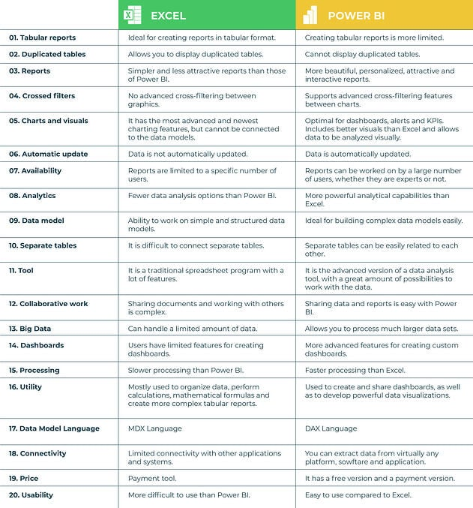

**Explain PowerQuery?**

Power Query is a data transformation and data preparation engine. Power Query comes with a graphical interface for getting data from sources and a Power Query Editor for applying transformations. Because the engine is available in many products and services, the destination where the data will be stored depends on where Power Query was used. Using Power Query, you can perform the extract, transform, and load (ETL) processing of data.

**Explain PowerMap?**

Microsoft Power Map for Excel is a three-dimensional (3-D) data visualization tool that lets you look at information in new ways. A power map lets you discover insights you might not see in traditional two-dimensional (2-D) tables and charts.

With Power Map, you can plot geographic and temporal data on a 3-D globe or custom map, show it over time, and create visual tours you can share with other people. You’ll want to use Power Map to:

**Map data**    Plot more than a million rows of data visually on Bing maps in 3-D format from an Excel table or Data Model in Excel.

**Discover insights**    Gain new understandings by viewing your data in geographic space and seeing time-stamped data change over time.

**Share stories**    Capture screenshots and build cinematic, guided video tours you can share broadly, engaging audiences like never before. Or export tours to video and share them that way as well.

**Explain the updates done in Power Bi Service(power BI 2.0) as compared to older version ?**

****Browse changes**** The left navigation links for ****Recent****, ****Favorites****, and ****Shared with me**** full page lists are being combined in a new ****Browse**** tab. You can still search and filter these lists, and now you can even filter by keyword.

****Left navigation changes**** A major change coming to the left navigation pane is tooltips. Before, to see what an icon represented in the left navigation pane, you had to expand the entire menu.

****Workspace flyout menu changes**** The ****My Workspace**** link moves below the ****Search**** box in the workspace flyout menu.

****Get Data changes**** The Get Data experience moves from the bottom of the left navigation pane to the ****Create**** tab.